**Group Gamma**

Julian Gomez Jr.

Jeremiah Kellam

Zachary Maziarz

Emily Wojan

CSD310

Module 11.1 Assignment

5/9/2023

Milestone #3

**Employee Hours Report**

In our Employee Hours Report, we are pulling back each employee's hours over the last 4 quarters. In this report, we are selecting from two separate tables we have created. One table is our employees, and the other is timecards. The employee's table houses employee information such as name, contact, employee id, address, position, etc. The timecards table has the employee id as a foreign key and shows the total hours worked for each associate per month. The table also displays PTO taken as well as non-paid time off taken during that month.

In this report, we return the employee id, a concatenation of the employee's first and last name, and a sum of the total hours that the employee has worked over the course of the last 4 quarters.

The following image is a screenshot of the Employee Hours Report:

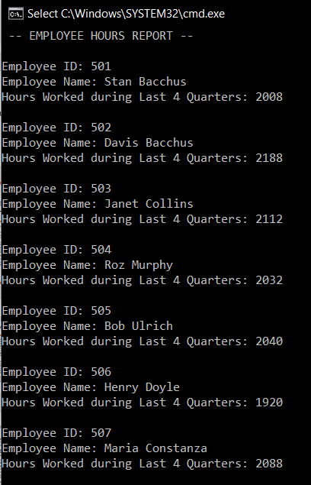

**Supply Order Report**

In our Supply Order report, we get the Supplier Name, the Supply Order ID, Order Date, the Estimated Delivery Date, the Actual Delivery Date, and the Delivery Gap. This report provides the company with a snapshot of each order they have made along with the supplier they ordered from and the gap between the estimated delivery date they gave and the actual delivery date of the items.

The report will display a positive number for the Delivery Gap if the Actual Delivery date is later than the estimated delivery date. The report will display a negative number for the Delivery Gap if the Actual Delivery date is sooner than the Estimated Delivery Date is given.

Delivery Gap will be based on calendar days between the estimated and actual delivery day, not business days.

The following is a screenshot of the Orders Report:

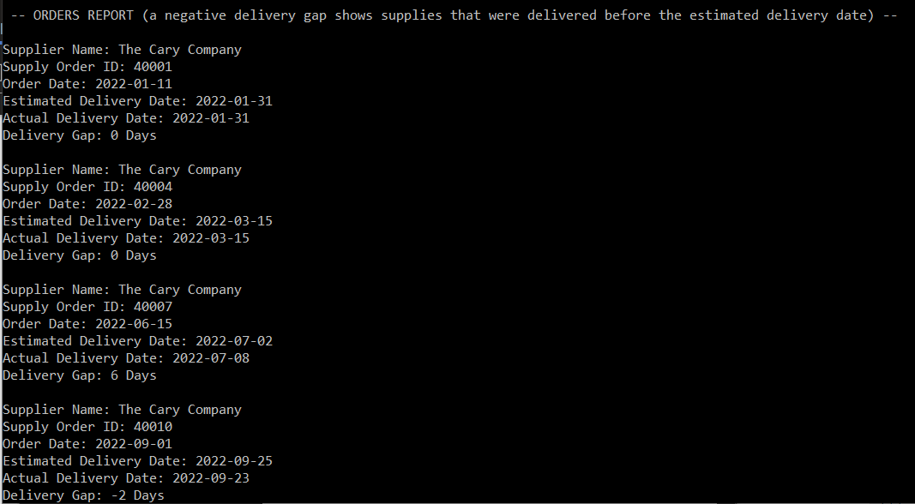

**Wine Sales Report**

In our Wine Sales report, we retrieve the Wine name, Units produced, Units sold, and Units remaining of each wine. This report provides the quantity sold of each wine and gives the stock amount in units that we still have on hand at the winery.

To calculate the amount produced reporting field, we took the sum of units on hand for each wine and the amount ordered for each wine. We then took the amount ordered to get the units sold. Lastly, we calculated the amount remaining of each wine by taking the sum of units on hand and units ordered and subtracting it from the units ordered.

Each wine (and its sales) was distinguished by its wine id from the database.

The following is a screenshot of the Wine Sales Report:

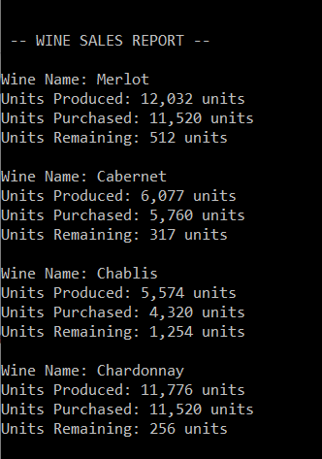

**Wine Distribution Report**

In our Wine Distribution report, we retrieved the Distributor name and Wine name in order to show which Distributor carries which wines.

The following is a screenshot of the Distribution Report:

